Rohan Raj

Faiz Haseem

T5

Task 1a:

addi x10,x0,12 # intializing a with value 12

addi x11,x0,12 # intializing b with value 12

jal x1,sum #calls the function named sum

addi x11,x10,0 # transferring the value in x10 to x11 so we can print it

li x10,1 # loads the value 1 into register x10

ecall

j exit #jumps to exit

sum: # sum function begins

add x10,x11,x10 # values in x10 (which is a) and x11 (which is b) are added and stored in x10

jalr x0,0(x1)

exit: # program ends

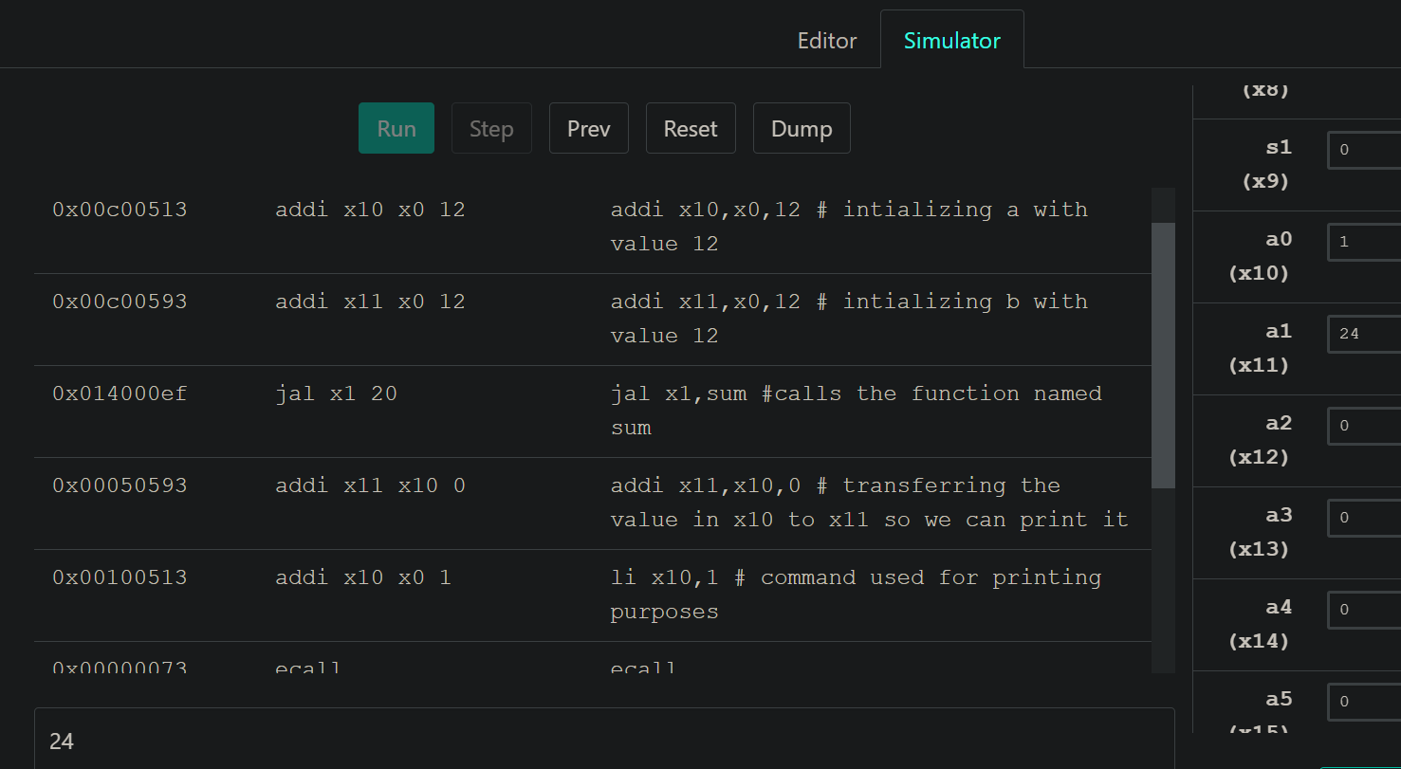

Task 1b:

addi sp, sp, -12 # adjust stack to make room for 3 items

sw, x5, 8(sp) # save register x5 for use afterwards

sw, x6, 4(sp) # save register x6 for use afterwards

sw, x20, 0(sp) # save register x20 for use afterwards

jal x1, function # calls the function named sum

addi, x11, x20, 0 # moving the value stored in x20 to x11

lw x20, 0(sp) # loading value in x20 to 1st memory in sp, i.e. x5

lw x6, 4(sp) # loading value in x20 to 1st memory in sp, i.e. x5

lw x5, 8(sp) # loading value in x20 to 1st memory in sp, i.e. x5

addi sp, sp, +12 # adjust stack to make room for 3 items

li x10,1 # loads the value 1 into register x10

ecall

j exit # jumps to exit

function:

add x5, x10, x11 # register x5 contains g + h

add x6, x12, x13 # register x6 contains i + j

sub x20, x5, x6 # f = x5 - x6, which is (g + h) - (i + j)

jalr x0,0(x1)

exit: # program ends

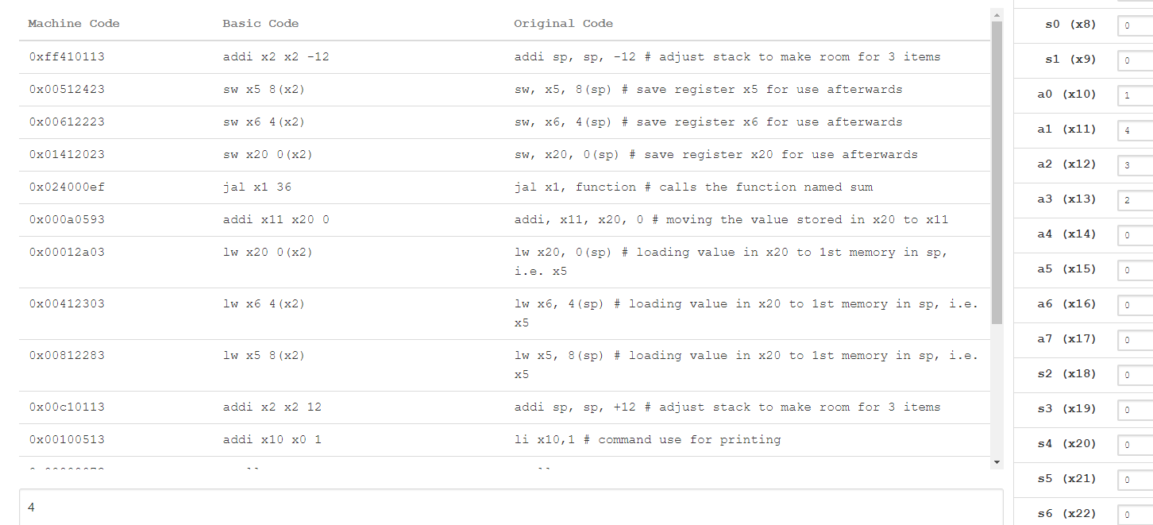

Task 1c:

addi x10, x0, 7 # initializing v[] with value 7

addi x11, x0, 4 # initializing k with value 4

sw x10,0(x6) # storing value of x10 in array[0]

sw x11,4(x6) # storing value of x11 in array[1]

jal x1,swap # jumps to swap function

swap:

addi sp, sp, -12 # reserving space in stack

sw x10, 8(sp) # storing value of x10 in stack [3]

sw x11, 4(sp) # storing value of x11 in stack [2]

sw x6, 0(sp) # storing value of x6 in stack [1]

slli x6, x11, 2 # shifting 2 units to the left

add x6, x10, x6 # adding the value of v[] to x6

lw x5,0(x6) # loading the value in x5 from array[0]

lw x7, 4(x6) # loading the value in x7 from array[1]

sw x7,0(x6) # storing value of x7 in array[0]

sw x5, 4(x6) # storing value of x5 in array[1]

# Releasing the stack

lw x6,0(sp)

lw x11, 4(sp)

lw x10, 8(sp)

addi sp, sp, 12

